Exp 1
a <- c(1,2,3,4,5,6)
print(paste("Type: ", class(a)))

b <- c("Gokul","Rahul","Dhanush")
print(paste("Type: ", class(b)))

c <- c(TRUE,FALSE,TRUE,FALSE)
print(paste("Type: ", class(c)))
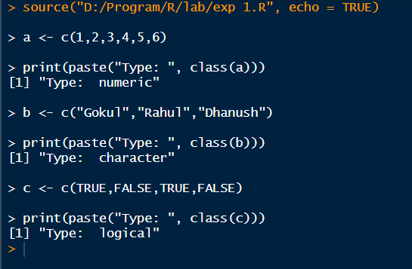

Exp 2
a = matrix(1:20, nrow=5, ncol=4)
a

b = matrix(1:9, nrow=3, ncol=3)
b

c = matrix(1:4, nrow=2, ncol=2)
c
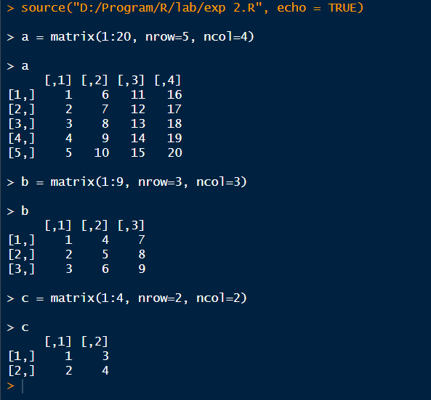

Exp 3
a = 1:24
arr = array(a, dim=c(2,3,4))
arr

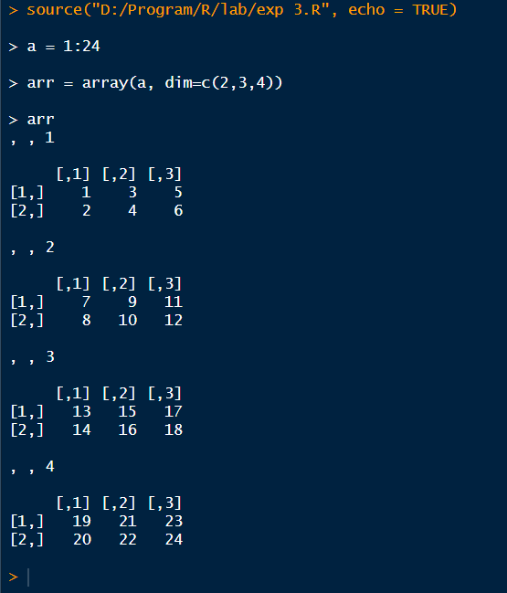

Exp 4
a = 1:8
b = array(a, dim=c(2,2,2))
b
print(b[2,1,2])

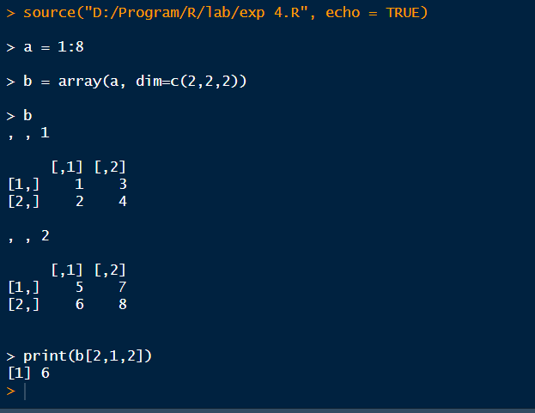

Exp 5
a = c("Short","Medium","Tall","Medium","Tall","Short")
b = factor(a)
print(b)

set.seed(10)
c = sample(LETTERS[1:5], 8, replace=TRUE)
d = factor(c)
print(d)
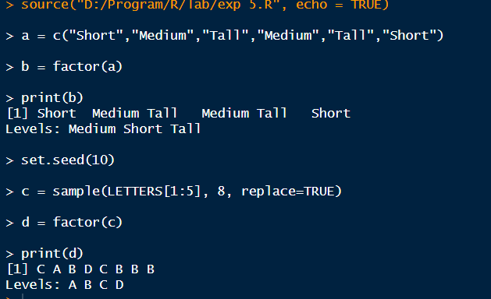

Exp 6
a = c(1,2,3,4)
b = matrix(1:6, nrow=2, ncol=3)
c = function(x) x^2

mylist = list(Vector=a, Matrix=b, Function=c)
print(mylist)

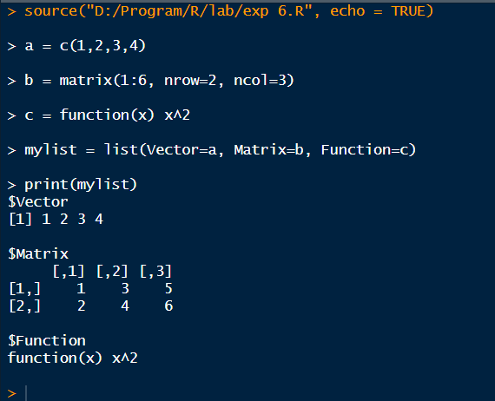

Exp 7
set.seed(123)
print("10 random integers:")
print(sample(-50:50, 10, replace=TRUE))

for (i in 1:100) {
if (i %% 15 == 0) {
print("FizzBuzz")
} else if (i %% 3 == 0) {
print("Fizz")
} else if (i %% 5 == 0) {
print("Buzz")
} else {
print(i)
}
}
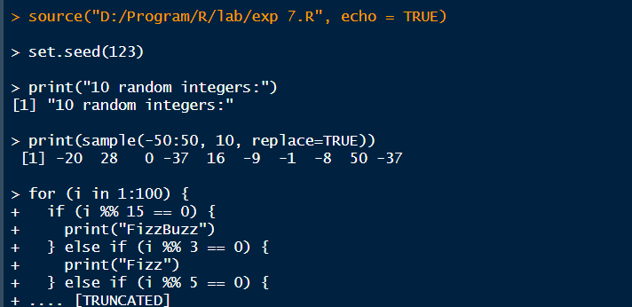
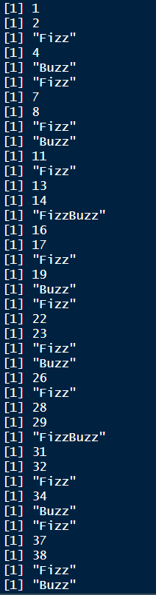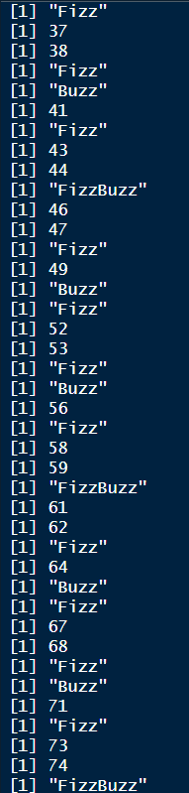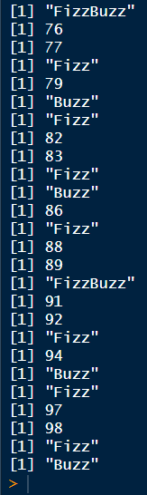

Exp 8
set.seed(123)
x <- rnorm(100)
y <- table(round(x))
print(as.data.frame(y))
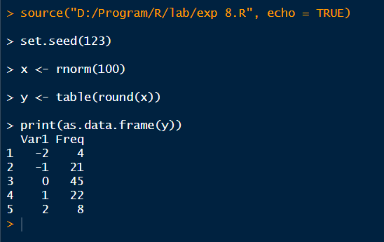

Exp 9
rm(c)
plot(1, type="n",
xlim=c(0,10),
ylim=c(0,100),
xlab="x axis",
ylab="y axis")
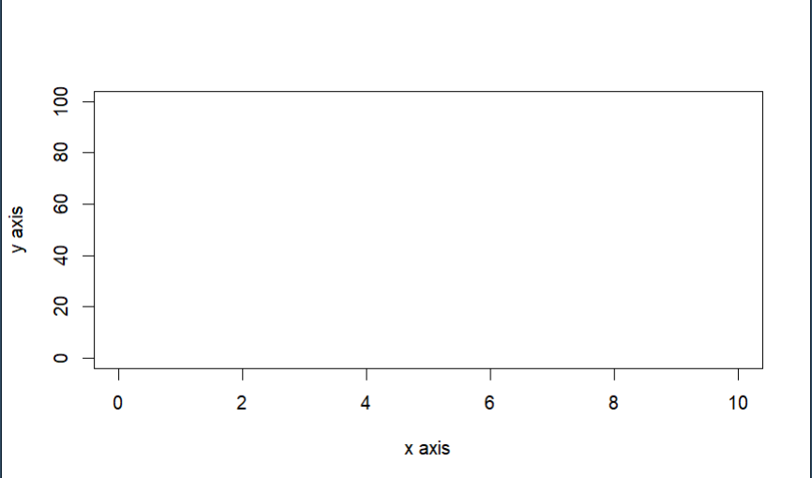

Exp 10
x <- data.frame(
name=c("Anu","Bala","Charan","Divya","Esha"),
score=c(85,62,90,75,88),
attempts=c(1,3,2,2,1),
qualify=c("yes","no","yes","no","yes")
)

x <- rbind(x, data.frame(name="Farhan",score=70,attempts=3,qualify="no"))
x$grade <- c("A","C","A+","B","A","B")

x <- x[order(-x$score),]
write.csv(x,"x.csv",row.names=FALSE)
print(x)
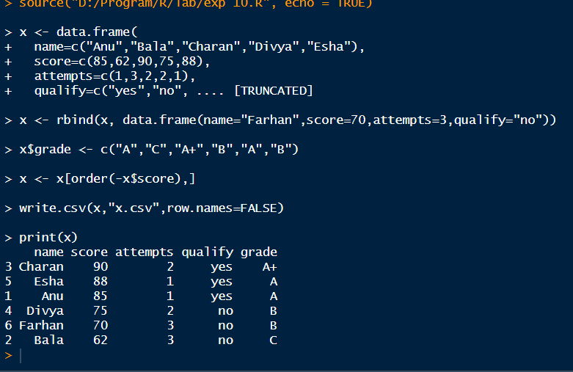

Exp 11
data <- read.csv("D:/Program/R/students_copy.csv")
print("Contents of the CSV file:")
print(data)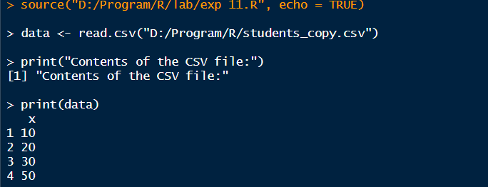

Exp 12
data("airquality")
result <- aggregate(cbind(Ozone,Solar.R,Wind,Temp) ~ Month,
data=airquality,
FUN=mean,
na.rm=TRUE)
print("Monthly average values:")
print(result)
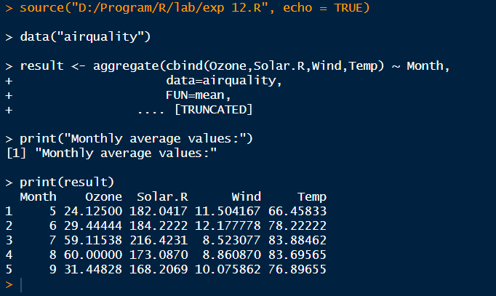

Exp 13
rm(list=ls())

a <- c(1,2,3)
b <- c(4,5,6)
c <- c(7,8,9)

d <- rbind(a,b,c)
print("Combined arrays (row-wise):")
print(d)
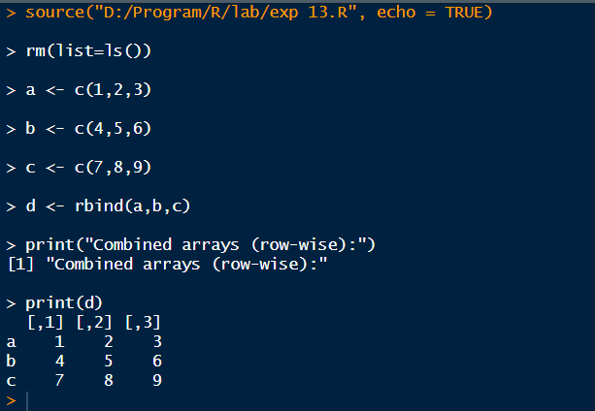

Exp 14
data("ChickWeight")
head(ChickWeight)

sorted <- ChickWeight[order(ChickWeight$weight),]
print(sorted)

aggregate(weight ~ Diet, ChickWeight, mean)
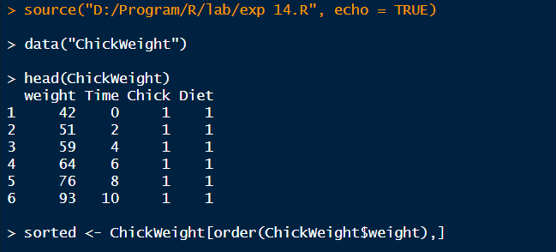
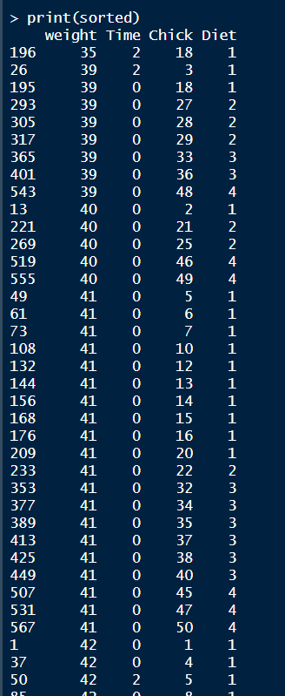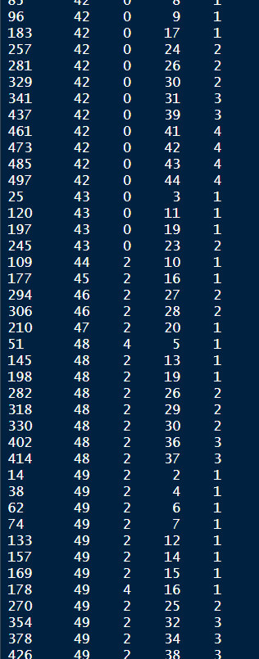
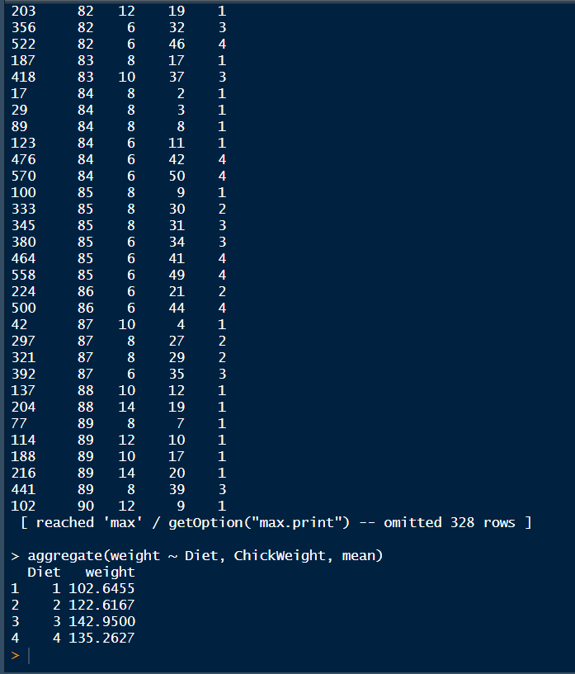

Exp 15
data("iris")
dim(iris)
summary(iris)
sapply(iris[,1:4], sd)
quantile(iris$Sepal.Length)
aggregate(. ~ Species, iris, mean)
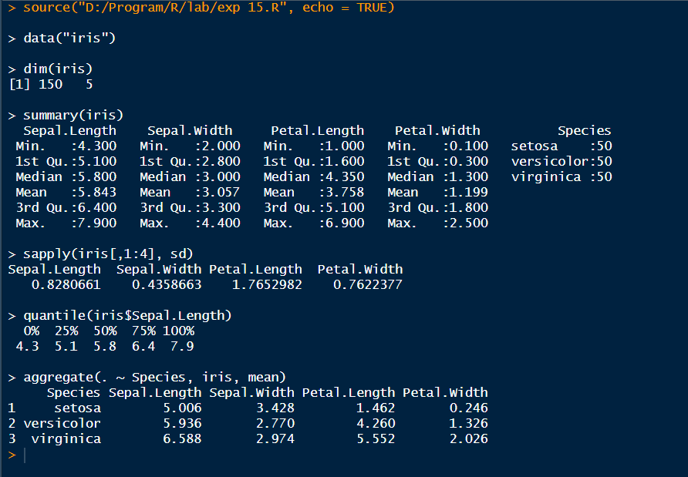

Exp 16
data("USArrests")
summary(USArrests)
which.max(USArrests$Rape)
max(USArrests$Murder)
min(USArrests$Murder)
cor(USArrests)
hist(USArrests$Murder)
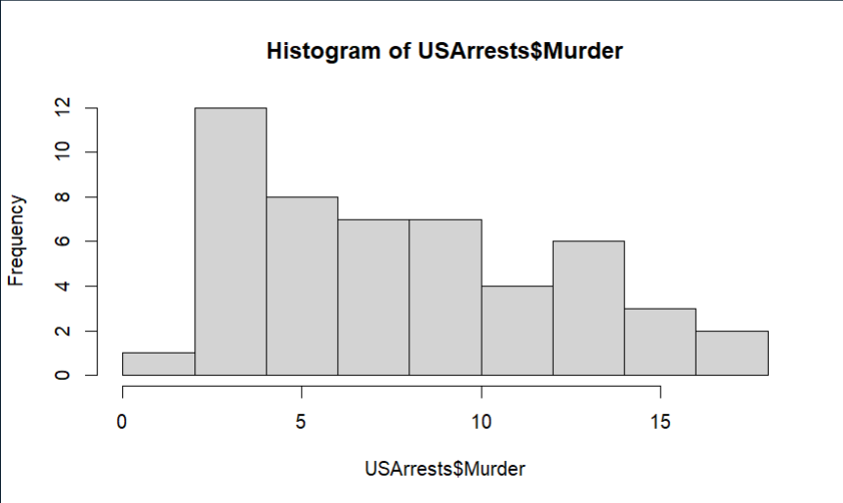

Exp 17
data("Titanic")
t <- as.data.frame(Titanic)

barplot(table(t$Class, t$Survived),
main="Survival vs Class", beside=TRUE)

barplot(table(t$Sex, t$Survived),
main="Survival vs Gender", beside=TRUE)

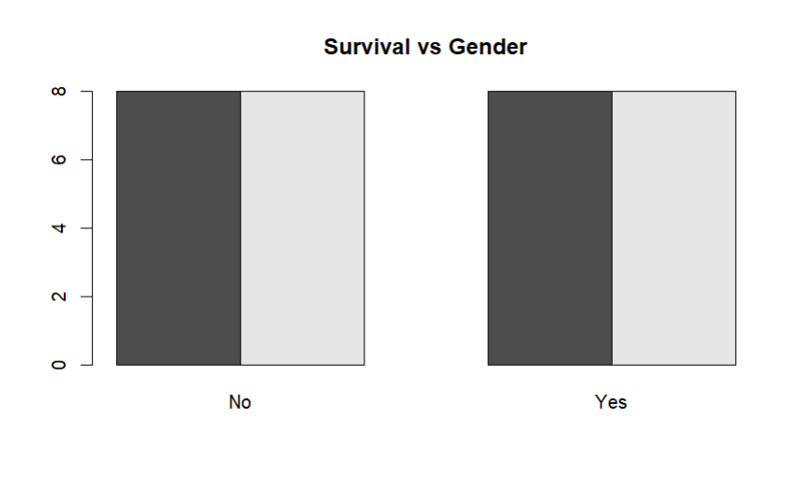

Exp 18
x <- c(10,20,30,40,50)
y <- c(5,15,25,35,45)

par(mfrow=c(2,3))

boxplot(x, main="Boxplot", col="lightblue")
hist(x, main="Histogram", col="lightgreen")
barplot(x, main="Bar Plot", col="orange", names.arg=c("A","B","C","D","E"))
plot(x, type="l", main="Line Chart", col="blue")
plot(x,y, main="Scatter Plot", col="red")

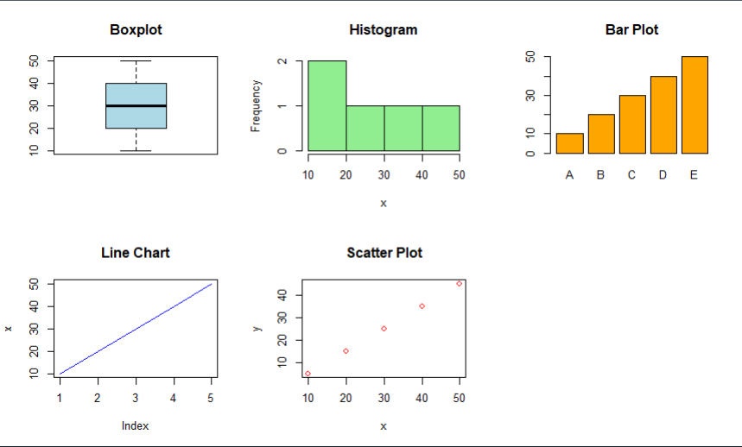

Exp 19
Spend <- c(10,20,30,40,50)
Sales <- c(15,25,35,45,55)

model <- lm(Sales ~ Spend)
predict(model, data.frame(Spend=60))

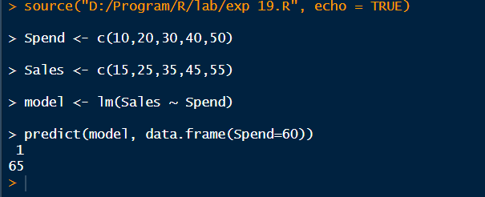

Exp 20
data("ChickWeight")
m <- lm(weight ~ Time + Diet, data=ChickWeight)
p <- predict(m)
mean((ChickWeight$weight - p)^2)
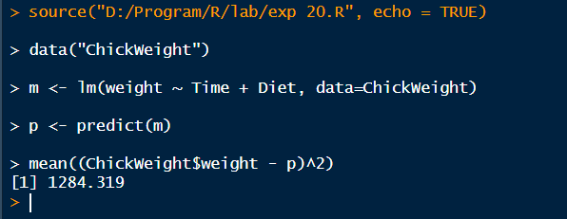

Exp 21
data("iris")

iris_sub <- subset(iris, Species %in% c("setosa","versicolor"))
m <- glm(Species ~ Petal.Length + Petal.Width,
data=iris_sub, family=binomial)

p <- ifelse(predict(m, type="response") > 0.5,
"versicolor","setosa")

table(p, iris_sub$Species)

